Episcopal Church Women
Diocese of Ohio

Annual Meeting and Committee Reports
2016 – 2017
As of 6/1/2017

Contents
140th Annual Meeting of the Episcopal Church Women, Diocese of Ohio 3
President’s Report 5
United Thank Offering Report 6
Resolutions Report 9
Nominating Committee Report 12
Seamen’s Church Institute/Christmas at Sea Report 12
The Order of The Daughters of the King Report 13
Worship Chair Report 14
Mission Area Reports 15
Financial Report 16
Income Statement 17
Balance Sheet 19
Income and Expense by Category 20

140th Annual Meeting of the Episcopal Church Women, Diocese of Ohio

EPISCOPAL CHURCH WOMEN, DIOCESE OF OHIO
140th ANNUAL MEETING, APRIL 22, 2017
GRACE EPISCOPAL CHUCH, MANSFIELD

Call to order and welcome: Barbara Jones called the meeting to order at 10:07 a.m. Barbara requested two (2) tellers to count the ballots. Nancy Sherwin and Lois Fogt-LaFountain offered to be the tellers. The Rt. Rev. Arthur Williams offered the opening prayers.
Barbara introduced The Rev. Daniel Orr. Daniel provided a brief explanation of the lay of the building.
Credentials Report: Rose Ann Brennan reported that 35 ECW members, two clergy and one non-voting visitor present.
Barbara continued to introduce her full board by name to include elected officers, appointments, and Mission Area ECW Presidents, and The Right Rev. Mark Hollingsworth, Jr., ex-officio.
Carol Culp made a motion to adopt the rules of the meeting, Nancy Sherwin seconded. The vote carried unanimously.
Treasurer’s Report: Rose Ann Brennan read her summary project budget report program year 2017 to 2018. The financial report will be filed for review.
Minutes from the 139th Annual Meeting: minutes have been read and will be filed. Carol Culp stated that since the Diocesan Council has recently dispensed with approving the annual minutes, ECW can too, dispense with approving the annual minutes.
Nominating Committee Report: Janet Smart, Nominating Chair, along with Lois Fogt-LaFountain and Suzette Reynolds, reported that the following have accepted positions to be filled:
- Vice President – Susan Little
- UTO Diocesan Coordinator – Linda Smith
- Secretary – Susan Quill
- Triennial Delegates – Frances Hummer, Susan Little, Hilary Nerby, Susan Quill

Janet referred to the nominees’ biographies in the packet.

Janet asked for any additional nominations from the floor for each of the open positions of Vice President, Secretary, and UTO Diocesan Coordinator.
- Carol Culp made a motion to close the nominations for Vice President and instruct the Secretary to close the ballot, Lois Fogt-LaFountain seconded. A unanimous vote in favor to close the ballot for Vice President was passed.
- Susan Little made a motion to close the nominations for Secretary and instruct the Secretary to close the ballot, Gretchen Tucker seconded. A unanimous vote in favor to close the ballot for Secretary was passed.
- Nancy Sherwin made a motion to close the nominations for UTO Diocesan Coordinator and instruct the Secretary to close the ballot, Lois Fogt-LaFountain seconded. A unanimous vote in favor to close the ballot for UTO Diocesan Coordinator was passed.

Resolutions: Carol Culp read the following resolutions:
- Resolution in Support of the Hunger Relief Efforts in the Diocese of Ohio Through Supporting the Hunger Network in Ohio and Local Food Programs
A unanimous vote in favor to approve the resolution was passed.
- Resolution in Support of the Episcopal Diocese of Ohio Partnerships with the Diocese of Belize, Province of the West Indies and the Diocese of Tanga, Province of Tanzania
A unanimous vote in favor to approve the resolution was passed.
Committee Reports: Barbara instructed members to refer to the packets to read the committee reports presented.
President’s Report: Barbara read her report. She explained that she took over the President’s position from Hilary Nerby who stepped down in September 2016.
Barbara read the election results in ranked order:
Susan Quill
Susan Little
Frances Hummer
Hilary Nerby
Carol Culp read a courtesy resolution that offers gratitude to Grace Episcopal Church for hosting this meeting, Pat Squire moved to accept the courtesy resolution. A unanimous vote in favor to accept the courtesy resolution was passed.
There being no further business, the meeting recessed at 11:10 a.m.
Susan Quill
Secretary

President’s Report

Hilary Nerby found it necessary to step down as president of the Diocese of Ohio ECW in October 2016; as vice president, I moved up to diocesan president at that time. As Immediate Past President, Hilary remains an active member of our ECW board, which meets five times each year at various locations around the diocese. The board includes both elected and appointed officers, mission area ECW presidents, and a representative of the Daughters of the King.
The ECW continues its involvement in the Diocese of Ohio partnerships with the Anglican Diocese of Belize, Province of the West Indies and the Anglican Diocese of Tanga, Province of Tanzania. In January 2017, I travelled to Belize with several others from the Diocese of Ohio, including Bishop Hollingsworth, to review the areas of joint mission and make plans for the future. An agreement was signed by the two bishops to continue the relationship between the two dioceses. English is the official language in Belize, because it was colonized by Great Britain and was formerly known as British Honduras.
The Diocese of Ohio ECW and the St. Timothy’s, Macedonia, ECW jointly received a $4,000 grant from the Diocese of Ohio Commission on Global and Domestic Mission (CGDM) to support the feeding program in the Anglican schools in Belize. There are around 25 Anglican schools. Hilary and I are both long-time members of CGDM, and Nancy Sherwin is a past member. Hilary and I have both been the grants chairman at different times, and I am currently the Secretary and Treasurer. Hilary and I have both visited the Anglican Diocese of Belize.
During my visit to Belize, I presented the grant check to Bishop Philip Wright. I also had the opportunity to visit “Clothesline,” a program that provides clothing and shoes free of charge to the local community. The shop and storage areas were hit hard by Hurricane Earl this past August, which destroyed most of the inventory. So far the Diocese of Ohio has made two shipments of clothing and shoes to restock the racks at Clothesline and provide footwear. In addition, two large shipments of medicine bottles have been sent by the ECW to Belize. These have been very much appreciated; medical clinics in Belize have medicine to distribute, but there is a shortage of suitable containers. Many parishes and individuals in our Diocese have donated to these efforts for Belize. The most recent shipment of medicine bottles went to a clinic in Belmopan, which is the capital of Belize.
Representatives from the Diocese of Belize have visited the Diocese of Ohio in the past, and two people from Belize were here for Happening several weeks ago.
Regarding the Diocese of Ohio relationship with the Anglican Diocese of Tanga, in Tanzania, plans are currently being made for several representatives from the Diocese of Ohio to travel there in late May. Bishop Alan Gates of the Diocese of Massachusetts (formerly rector of St. Paul’s, Cleveland Heights) will also be going, because the Diocese of Massachusetts also has a relationship with that Diocese. Some of you may remember Elizabeth Mavoa from Tanga, who was a special guest at our ECW annual meeting in 2013.
Looking ahead, four of us (Hilary Nerby, Linda Smith, Janet Smart, and I) will travel next week to the Province V ECW in Lansing, which is in the Diocese of Western Michigan. Province V covers Illinois, Indiana, Michigan, eastern Missouri, Ohio and Wisconsin: 14 dioceses, 844 congregations, 220,000 lay persons and clergy.
Next year’s Province V meeting will be held at the DeKoven Center, Racine, Wisconsin.

United Thank Offering Report

UNITED THANK OFFERING REPORT
Diocese of Ohio ECW Meeting
April 22, 2017
The United Thank Offering (UTO) is a ministry of the Episcopal Church for the mission of the whole church. Through UTO, men, women and children nurture the habit of giving daily thanks to God. Those who participate in UTO discover that thankfulness leads to generosity. UTO is entrusted to promote thank offerings, to receive the offerings, and to distribute the UTO monies to support mission and ministry throughout the Episcopal Church and invited provinces of the Anglican Communion in the developing world.
The United Offering was established at the Triennial of 1889. The United Offering became the United Thank Offering in 1919. In the 1943 triennium, the UTO offering surpassed the $1 million mark for the first time. In 1949, it increased to almost $2 million. UTO granted more than $3 million a year for the first time in 2000.
Parish ingatherings may be held one or two times per year. The suggested day for the Spring Ingathering is the Sunday closest to Ascension, and the suggested day for the Fall Ingathering is the Sunday closest to All Saints’ Day in November. United Thank Offering contributions from the Diocese of Ohio totaled $17,620.40. From 2000 to 2016, the Diocese of Ohio received $219,553 in grants from UTO (11 grants).
In 2016, the United Thank Offering of the Episcopal Church awarded 32 grants for a total of $1,161,314.62 for the mission and ministry of the Episcopal Church and the Anglican Communion. The 2016 grants were awarded to projects in 32 dioceses, which included 25 dioceses located in the United States, five non-domestic dioceses, six companion dioceses, one grant to the Office of the Presiding Bishop – Episcopal Migration Ministries, and one Presiding Bishop Grant. The grants ranged from $3,112 to the Diocese of Missouri to $98,000 to the Dioceses of Rumonge, Matana, Gitega, and Muyinga, Province of Burundi.
In February 2017, special United Thank Offering grants for seven seminarians and four young adults were awarded.
In 2017, two UTO grant applications were submitted in the Diocese of Ohio. A screening reviewed the applications to ensure that they were complete, were presented on the current year’s application form, and met this year’s criteria. One application met the criteria. The screening committee unanimously recommended that application to Bishop Hollingsworth. He has submitted it to the UTO Board with his letter of support.
A variety of UTO supplies (offering boxes, envelopes, pocket blue boxes, handbooks, litanies, bookmarks, placemats, etc.) are available at
http://episcopalmarketplace.org/Products/United-Thank-Offering

Many are free; some have a nominal cost. Be aware, however, that shipping charges may add significantly to the cost of your order.
Linda Smith
Diocese of Ohio UTO Coordinator
Phone (330) 348-4756
E-mail: smithllh@yahoo.com

2017 UNITED THANK OFFERING GRANT POLICY & CRITERIA

The 2017 UTO grant application and materials were available beginning December 2, 2016. The deadline for submission of 2107 grant applications to the Diocese was February 17, 2017. The Focus and Criteria change from year to year.

The United Thank Offering Grant Session is held during the Spring UTO Board Meeting; announcement of 2017 grant awards is expected to be made in June.
The 2017 United Thank Offering Grants session focuses on the Jesus Movement.
A United Thank Offering grant application must:
- spend grant money within one year of receipt of the grant
- return the final report of the funds within one year of the receipt of the grant
- show a connection with the Episcopal Church or Anglican Communion
- show that any property, land or structure, is owned by an Episcopal congregation or diocese
- show financial or in-kind support

The United Thank Offering will accept:
- grant applications which are for start-up costs for a new ministry, not for the continuation of an ongoing ministry unless there is a definite new direction added to the existing program
- grant application for seed money for start-up positions, either full- or part-time for a new ministry
- one grant application per diocese within The Episcopal Church and one per invited province of the Anglican Communion
- one additional application from a diocese of The Episcopal Church for a Companion Diocese or a formalized relationship/partnership between two bishops with jurisdiction

The United Thank Offering will NOT fund:
- project site/programs for two consecutive years
- capital campaigns or debt reductions
- deferred maintenance
- operational budgets
- debts obligated or incurred before the date of the grant award
- stipends or honoraria
- employment benefits or fees, taxes, or social security costs
- purchase of consumable items
- maintenance or printing of marketing materials, or a website; however, the initial development/creation of materials, videos or a website can be funded
- fees of architects or engineers; insurance of any kind; shipping costs; background checks and fingerprinting
- contingency funds or overhead costs
- rent or leasing of any kind
- modifications or construction on property NOT owned by an Episcopal or an Anglican Communion entity
- scholarships, tuition, camp fees, or attendance incentives
- previously funded requests
- programs regarded to be diocesan operating budgets
- grant applications from an Episcopal or Anglican diocese that has a current delinquent/outstanding grant
- grant applications that have 51% or more of the total requested budget out of criteria
- emergency response requests (These should be submitted to Episcopal Relief and Development.)

In Episcopal dioceses within the United States, the United Thank Offering will not fund:
- a vehicle with a 12 or 15 passenger chassis (due to stability and insurance matters)
- any vehicles that are not the property of a church or diocese of The Episcopal Church
Additionally, the United Thank Offering:
- will only fund one-half of the amount of the cost of a vehicle requested in the United States

Please note – any grant application submitted that is not within the criteria guidelines will not be considered.

Resolutions Report

RESOLUTIONS PROPOSED FOR APPROVAL AT THE 140th ANNUAL MEETING
OF THE EPISCOPAL CHURCH WOMEN, DIOCESE OF OHIO

Resolution 1
A Resolution in Support of the Hunger Relief Efforts in the Diocese of Ohio
Through Supporting the Hunger Network in Ohio and Local Food Programs

Whereas: Jesus asked Peter to love Him by feeding his sheep (John 21:15-17), and
Whereas: Action to end hunger is most effective when informed and initiated at the grassroots level, and
Whereas: Increased communication on hunger issues in Ohio can strengthen efforts to influence local, state, and national hunger relief legislation, and
Whereas: The Hunger Network in Ohio (HNO) is a faith-based network of advocates who believe we can end hunger by addressing the root causes of poverty through public policy. HNO was founded in 1969, by our own Bishop John Burt and representatives from the Episcopal Diocese of Southern Ohio, the Evangelical Lutheran Church in America (ELCA), The United Church of Christ, United Methodists, and Presbyterians among others, and
Whereas: Currently Ohio ranks 44th in the nation with 1.85 million food insecure people, including many children and senior citizens, and
Whereas: Emergency food programs provide immediate assistance to families, especially with the help of the Ohio Association of Foodbanks and our local food pantries and soup kitchens, so that we are able to provide affordable and nutritious food to distribute in our communities.
Therefore be it resolved that
The Episcopal Church Women of the Diocese of Ohio work individually and through our parishes to make feeding the hungry a high priority. We urge our members to participate in the Hunger Network in Ohio (HNO), as well as local food programs. HNO can be supported by the 2-cents a meal program or a special collection. (Money should be sent quarterly to the Diocese of Ohio Chief Financial Officer, who will forward the total in one check to HNO.)
Be it further resolved that
Individually or through our parishes, we develop relationships with those who have control over hunger relief policy, in order to create long-term and systemic change. Hunger Network in Ohio can provide the latest information on meeting short- and long-term hunger relief goals (http://www.hungernetohio.com/).

Submitted by the Resolutions Committee

Resolution 2
A Resolution in Support of the
Episcopal Diocese of Ohio Partnerships with the
Diocese of Belize, Province of the West Indies and the
Diocese of Tanga, Province of Tanzania

Whereas: on November 12, 2016 the 200th Convention of the Episcopal Diocese of Ohio endorsed the continuing partnerships with the Anglican Diocese of Belize in the Province of the West Indies and the Anglican Diocese of Tanga in the Province of Tanzania, until Diocesan Council or Convention discern a different direction; and

Whereas: the Diocese of Ohio Episcopal Church Women have actively participated in both of these partnerships since their formation in 2011; and
Whereas: The Episcopal Church Women recently supported the school feeding program in Belize and have helped establish a Clothesline project modeled on one at St. Timothy, Perrysburg; and
Whereas: the current and immediate past Presidents of the Diocese of Ohio Episcopal Church Women have travelled to Belize and established relationships that will assist us as we discern future directions for our involvement in the Belize partnership;
Therefore be it resolved that
The Episcopal Church Women of the Diocese of Ohio continue to support the partnerships with the Diocese of Belize and the Diocese of Tanga; and
Be it further resolved that
The Episcopal Church Women of the Diocese of Ohio encourage their parishes and mission areas to support the partnerships.

Submitted by the Resolutions Committee

Nominating Committee Report

The nominating committee met on January 21, 2017 as a committee of the whole at the end of our ECW Diocesan Board meeting at Church of the Ascension in Lakewood to generate names for all open positions. In addition, we have been in contact via e-mail and phone calls to potential candidates.
The following have agreed to be candidates for the open positions:
Vice President: Susan Little
UTO Diocesan Coordinator: Linda Smith
Secretary: Susan Quill
Triennial Delegates: Frances Hummer, Susan Little, Hilary Nerby, Susan Quill

Each candidate’s priest has submitted a letter of recommendation.

Janet Smart, Nominating Chair
Lois Fogt-LaFountain
Suzette Reynolds

Seamen’s Church Institute/Christmas at Sea Report

I’m very pleased to note that this year everybody followed SCI’s instructions – everyone worked in the SCI-approved patterns, nothing in pastel yarn, no pompons or tassels, and lots of interesting yarns and combinations.

Church of the Ascension, Lakewood 18
St. Anonymous, Elsewhere 9
St. James, Boardman 2
St. James, Painesville 22
St. Mark, Canton 50
St. Nemo, Somewhere 9
St Thomas, Berea 3
Trinity, Toledo 11

St. Anon. & St. Nemo returned to the knitting fold this year as real parishes left – soon to return, one hopes. Chairing the Christmas-at-Sea project is like riding a roller coaster. While St. James Painesville does not attend ECW events, they’ve been knitting for the project for many years and ship their completed work directly to New Jersey.
Three cartons of knitting and crocheting were sent to Port Newark – 124 items in all.
Carol Culp
Liaison, Christmas at Sea

The Order of The Daughters of the King Report

ECW – Diocese of Ohio Annual Meeting – April 22, 2017
Report of The Order of The Daughters of the King
The Order of the Daughters of the King® is an order for women who are communicants of the Episcopal Church, churches in communion with it, or churches in the historic episcopate but not in communion with it. Our membership currently includes women in the Anglican, Episcopal, Lutheran (ELCA) and Roman Catholic churches. “The Order is a safe place in a busy world where women with similar interests can study, pray and share together.” The Order of the Daughters of the King, thus described in our National Study Guide, is 130 years old.
The DOK Diocese of Ohio meets twice a year in the Spring and Fall and has exhibits at church events periodically throughout the year. The 2017 Spring Assembly was held at Trinity Cathedral on 3/25/2017 as part of the Diocese Bicentennial Celebration. There were 22 attendees with several ECW members who enjoyed the fellowship and dialogue. The DOK had an exhibit at the Diocesan Winter Convocation held on 2/10/2017 at Kalahari Resort. Many attendees were interested in the literature. Our 2016 Fall Assembly was held on 11/5/2016 at Christ Church, Shaker Heights. There were 26 people in attendance with several guests. The program was presented by Rev. Vanessa Clark, Diocesan DOK Chaplain, on the history of and ways to pray the Anglican Rosary. This was followed by a workshop where each attendee made her own rosary. The DOK has an exhibit at this 2017 ECW Diocesan Annual Meeting held 4/22/2017 at Grace Church Mansfield. Feel free to ask me for information.
The DOK at Christ Church Shaker Heights hosted the Cuyahoga Mission Area ECW Easter Flower project on Easter Saturday, 4/15/2017. This is a fun project to assemble tray favors (a carnation with greenery in a water tube) for Easter morning. A total of 522 tray favors were delivered to Metro General Prentiss Center (175), VA Hospital (195), Hospice of the Western Reserve (42) and Shaker Gardens Nursing Home (110). Many Thanks to the ECW Diocesan Board for contributing funds to the mission area in support of this project.
The current diocesan officers are: Acting President & Vice President – Karen Swan (St. Martin’s Chagrin Falls); Treasurer – Ellen Cubberley (Christ Church Shaker Heights); and Secretary – Cathy Wolford (Christ Church Shaker Heights). Karen Swan will attend the DOK Province V Retreat/Assembly on 4/21-4/23/2017 and also future DOK Province V Board meetings as our diocesan representative. Cathy Wolford serves on the ECW Diocese of Ohio Board as the DOK representative.
You can recognize DOK members by the modified Greek fleury cross we wear. It is inscribed in Latin, Magnanimiter Crucem Sustine, the watchword of the Order, meaning "With heart, mind and spirit uphold and bear the cross." At the base of the cross are the letters "FHS," initials that stand for the Motto of the Order "For His Sake ... I am but one, but I am one. I cannot do everything, but I can do something. What I can do, I ought to do. What I ought to do, by the grace of God I will do. Lord, what will you have me do?".
If you have prayer requests, please let your local DOK chapter know, or you can email me and I’ll be sure to pass it on.
Cathy Wolford DOK Representative catwolf@roadrunner.com

Worship Chair Report
As the Worship Chair for 2016-17, I prepared and led worship to open the Diocesan ECW Board meetings of September 10, 2016 and January 21 and March 5, 2017. In addition, I coordinated the worship section of the Annual Meeting with Bishop Hollingsworth’s office.

I would like to thank Immediate Past President Hilary Nerby and current President Barbara Jones for their assistance as I felt my way through a new role; Bishop Hollingsworth, Eva Cole, Betty Kondrich and The Rev. Joe Ashby for their assistance in planning and putting together the Eucharist and worship bulletin for the Annual Meeting; and Rose Ann Brennan, Carol Culp, Frances Hummer and Janet Smart for serving during the service.

Respectfully submitted,
Elaine Willis, Worship Chair

Mission Area Reports

Cuyahoga Mission Area ECW

Christ Church, Shaker Heights, has again assembled 525 carnations as Easter Day tray favors for four area institutions, including Hospice of the Western Reserve and the Veteran’s Administration.

Human trafficking awareness continues to be a concern, having been a topic at a Mission Area meeting.

St. Matthew’s, Brecksville, ECW has begun a group for seniors, men included, focusing on social activities, such as visiting the Maltz Museum and service projects. ECW will be sponsoring a Mother’s Day Tea.

The medicine bottle project for Belize continues throughout the mission area.

Suzette Reynolds, President

Southeast Mission Area ECW
We are currently relatively inactive as a mission area. We do try to support each other’s parishes by our attendance when something special is going on there. The only parish with an active ECW which meets monthly is St. Stephen’s, East Liverpool.

Janet Smart, Past President & Acting President

Summit / Central East Mission Area ECW
The Summit / Central East Mission Area has met four times and will have a spring luncheon meeting in May. We continue to collect prescription pill bottles and summer clothing for Belize, new and slightly used bras for an Akron agency, and Box Tops for Education for Schreiber Elementary School in Canton. Because some agencies have more items than they can disperse, we are donating baby blankets to grass root agencies in our own area. Our mission area includes 5 counties.

Sue Little, President

West Mission Area

West Mission Area Council supports various functions in all northwestern Ohio churches but there are no formal, active ECW meetings in any of the churches. Announcements include any and all functions within the churches and they are conducted and supported by everyone.

Lois LaFountain, President WMA ECW, Secretary WMA Council

Financial Report
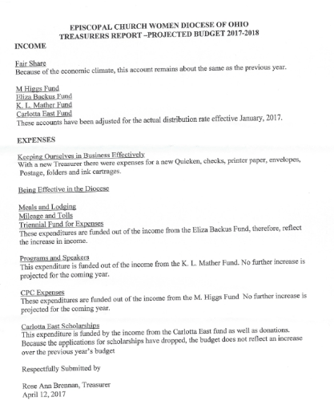

Income Statement
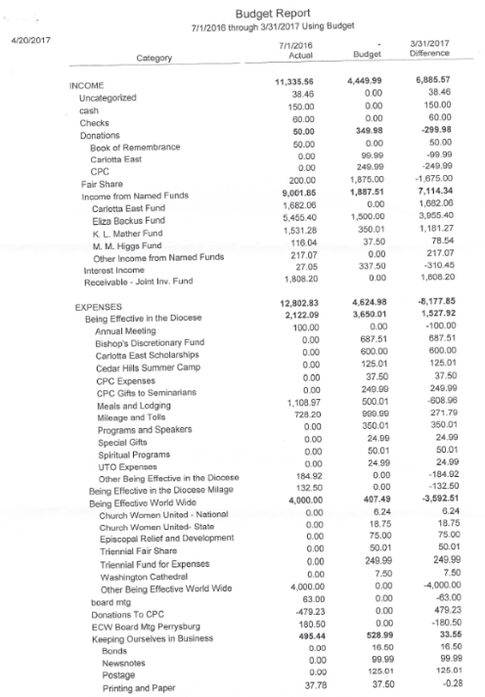
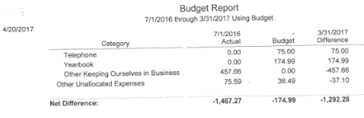

Balance Sheet
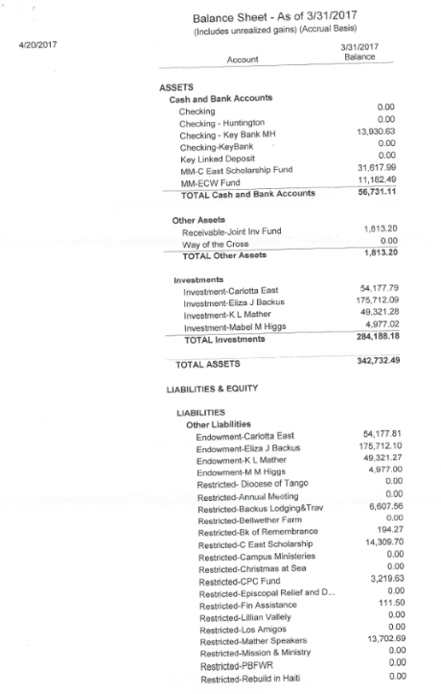
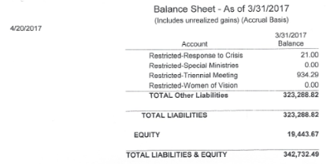

Income and Expense by Category

