Pretzels for Lent
February 17, 2010 By Lacy
Did you know that the pretzel is a traditional food for lent?
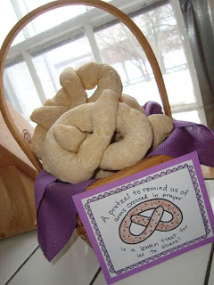
When early Christians would pray, they would cross their arms and touch each shoulder with the opposite hand. They also fasted very strictly during lent, making their bread with only water, flour, and salt. A monk shaped this in the form of praying arms for children, and the pretzel was born! To read more about the religious history of the pretzel and for the pretzel prayer, check out Catholic Culture’s pretzel page.
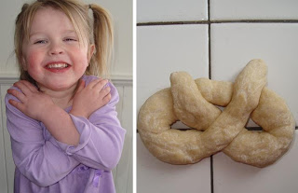

Soft Pretzel Recipe~ What you need:
- 1 package yeast
- 1 1/2 cups warm water
- 1 tablespoon sugar
- 1 tablespoon salt
- 4 cups flour
- 1 egg
Mix your yeast, water, sugar, and salt in a large bowl. Stir in the flour, and knead until the dough is smooth. Shape into the form of arms crossed in prayer and place it on a baking sheet. Brush the dough with a beaten egg to give it a shiny finish (I skipped the egg on mine). Sprinkle the top with salt, and bake in an oven preheated to 425 degrees for 15 minutes.
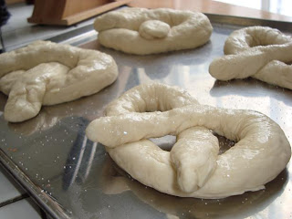
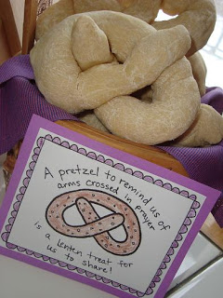
For fun, I drew out this Lenten Pretzel Card that reads “A pretzel to remind us of arms crossed in prayer is a Lenten treat for us to share!”. I uploaded it to share with all of you, so you can print it for free below!
Download Pretzel Prayer Printable for FREE here!

