Pretzels for Lent
March 2, 2012 By Jeff Young
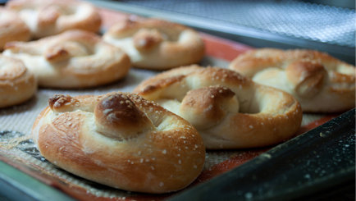

INGREDIENTS:
- 1 1/2 cups lukewarm water (about 110 F)
- 1 tablespoon honey
- 1 envelope active dry yeast (2 1/4 teaspoons)
- 4 cups all-purpose flour (we prefer King Arthur)
- 1 teaspoon Kosher salt
- Coarse salt (for topping)
- 1 egg, beaten

DIRECTIONS:
- Add the honey to 1 1/2 cups warm water (about 110 F). You don’t want the water too hot… that would kill the yeast.
- Add the yeast and stir until dissolved.
- Add 1 tsp salt and stir until dissolved.
- Blend in the flour using a fork. When the dough begins to pull away from the bowl, lay it out on a hard surface and knead till smooth.
- Cut the dough into pieces… about the size of the palm of your hand.
- Roll each piece into “ropes” by hand, then twist into pretzel shapes.
- Place the pretzels on baking stones (or lightly greased cookie sheets)
- Brush each pretzel with the beaten egg and sprinkle with salt.
- Bake at 425 F for 12 to 15 minutes (or until golden brown).
Enjoy! [Moderately, though... It is Lent after all.]
And speaking of Lent… If you want to learn more about Pretzels and Lent, you might want to visit these sites:
- Pretzels For God: Lent and the Pretzel
- Lenten Pretzels
- Pretzels for Lent (on Catholic Icing)
This recipe was adapted from one I first found on DanielleBean.com a couple of years ago. Danielle originally got it from from A Continual Feast by Evelyn Birge Vitz.
***Pretzel image courtesy of BohemianDolls on Flickr.com***

